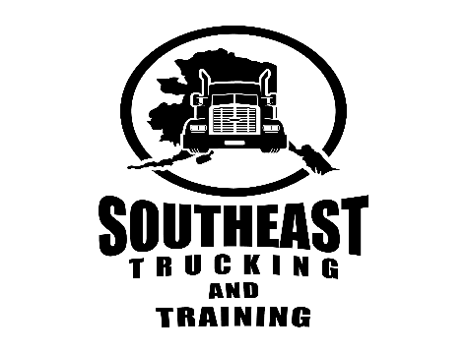

Course Description
With the growing demand for qualified and well-trained drivers, SETT has developed a comprehensive program to train and educate students. This training is based on the standards set forth by the Federal Motor Carrier Safety Administration for Entry Level Driver Training requirements. Our instructors have their certification from CVTA.org (Commercial Vehicle Training Association) and other sources of additional training including their own personal driving history in a CMV. The Commercial Vehicle Training Association is the largest association representing commercial truck driver training programs in the United States. CVTA members represent nearly 200 training providers in 42 states and collectively train over 50,000 commercial drivers annually. Their primary mission is to advance and support the commercial truck driver training industry through advocacy, education programs, and certification programs to help members produce the safest drivers possible. SETT curriculum is by J.J Keller. They were established in 1953, with experts offering advanced, current technology, providing confidence in Training Schools or Employers to assure they are meeting all requirements of DOT, FMCSA, OSHA, EPA, and more. Our program meets the ELDT Federal curricula requirements by DOT and the FMCSA (Federal Motor Carrier Safety Administration) that went into effect 2/7/22.

SETT Training consists of classroom instruction and online courses. BTW (Behind the Wheel) time will be 40 hours in combination of off road (range) and on-the-road driving. Your hours will be documented by the instructor and each topic set forth by the FMSCA will be covered and logged in the students record folder and retained for 3 years per the FMCSA requirement. The additional 4 hours is allotted for the fine tuning and testing day at DMV or with our 3rd Party Examiner. This course was designed for drivers seeking their class “A” or class “B” CDL license, with an option for additional HAZMAT training or Passenger Endorsement training. This training gives drivers in combination of 114 hours, but no more than 15 working days, to develop all the skills needed to be successful in taking the CMV Driving Road Test. Our program is flexible, and individual based and SETT will work around your time availability and schedule.
The FMCSA requires that all the theory and road training be at the grading scale of 80% or higher to be eligible to apply for your CDL after completion. Once your training is completed and all subjects covered and passed, the Administrator will enter your information on the Training Provider Registry (TPR) no later than 2 business days after course completion. Once it has been approved, you will be scheduled and able to take the skills driving test with Division of Motor Vehicles (DMV) or with SETT in the SETT training vehicle. Upon passing, DMV will issue your CDL license.
​
Course Requirements
Prerequisites:
- High School Diploma or GED
- Applicant must be at least 18 years of age, 21 years for HAZMAT endorsement
- Applicant must have an Alaska Driver’s License for at least one year
- Applicant must have a Social Security Card
- Applicant must provide a Driving Record, not older than 30 days prior to the start of training (Administrator will assist with this once you are accepted)

Any of the following violations will prevent a prospective student from applying to the program:
- Two traffic citations, 15 mph over the posted speed limit in a two-year period.
- One traffic citation, 15mph over the posted speed limit with a suspension or revocation
in a two-year period.
- A suspension and a revocation within a two-year period.
- A total of 10 points on your driving record in the last two years.
- A total of three moving violations in the last two years.

If the prospective student meets the above criteria, the student will meet with the Administrator, discuss their financial plans, collect the $500 nonrefundable deposit (for any non-funded applicants) and SETT will arrange the appointments for the Department of Transportation (DOT) physical (also known as the medical card) and the FMCSA/DOT Drug Test with TSS. The drug test must be done within 10 days prior to start of class. Student must have a negative drug test, or they will be disqualified.

